Infosys Springboard Virtual Internship 7.0 Completion Report

Team Details
Batch Number-02
Start date-15th July 2026
Names: Puspal Das | Mittapalli Praharsha | Muthyala Meghana | Ramanaboina Sowjanya
Internship Duration: 8 Weeks

1. Project Title
Intelligent Farm Operations Platform with Smart Agro Precision System

2. Project Objective
The primary goal of the FarmVerse project is to digitize and optimize traditional agricultural practices by developing a unified, Java Full-Stack Precision Agriculture Management Platform.
The project aimed to achieve this by centralizing critical farming operations into a single ecosystem. It successfully integrates a gamified farmer dashboard to drive daily digital engagement, a secure digital marketplace that eliminates traditional middlemen to ensure fair pricing, and a real-time Generative AI advisory system (powered by Google Gemini) that provides instant, data-driven solutions for crop and pest management.
Its relevance to the organization (and the broader agricultural sector) lies in bridging the technological gap for rural communities. By transforming fragmented, manual farming methods into a secure, cloud-based workflow utilizing modern technologies (Spring Boot, MongoDB, and AI), FarmVerse significantly empowers farmers to make informed decisions, optimize their crop yields, and maximize their economic returns.

3. Project description in detail
1. Project Overview FarmVerse is a robust, Java Full-Stack Precision Agriculture Management Platform designed to modernize and streamline traditional farming workflows. The project serves as a centralized digital ecosystem that bridges the technology gap for farmers. It successfully consolidates agricultural advisory, crop lifecycle management, and a secure farmer-to-buyer digital marketplace into a single, highly accessible web application. By shifting farmers away from fragmented, manual processes, FarmVerse provides a data-driven environment that optimizes farm productivity and profitability.
2. Approach and Methodology The development of FarmVerse followed an agile, modular approach, separating the architecture into three distinct layers to ensure security, scalability, and performance:
- User-Centric Design (Frontend): Recognizing that technology adoption can be low in rural sectors, the frontend was designed to be lightweight, responsive, and engaging. A "Gamification Engine" was implemented, utilizing Experience Points (XP) and daily missions to encourage consistent user engagement.
- Secure API Architecture (Backend): The backend was structured as a secure RESTful API. JSON Web Tokens (JWT) and Spring Security were implemented to enforce strict Role-Based Access Control (RBAC), ensuring that Farmers, Administrators, and Agricultural Experts only have access to their authorized data and modules.
- AI Integration: Instead of relying on static, hardcoded advisory systems, an innovative approach was taken to integrate real-time Generative AI. The system communicates securely with Google's Gemini LLM to provide context-aware agricultural advice. To ensure enterprise reliability, custom retry logic was engineered into the backend to handle high server demand and network latency gracefully.
3. Technologies Used The project was built using a modern, scalable technology stack:
- Frontend: HTML5, CSS3, and Vanilla JavaScript (Ensuring ultra-fast load times without heavy framework overhead).
- Backend: Java 21, Spring Boot 3.x, Spring Web, and Spring Security.
- Database: MongoDB Atlas (A Cloud NoSQL database chosen for its flexibility in storing unstructured AI chat histories and complex marketplace metadata).
- AI Engine: Google Gemini 3.6 Flash API (Integrated via Spring RestTemplate).
- Build & Deployment: Maven.
4. Real-World Impact and Implementation In a real-world implementation, FarmVerse carries immense socio-economic impact for the agricultural sector:
- Eradicating Middlemen: The integrated Digital Marketplace allows farmers to list their harvests and sell directly to buyers. This transparent commerce model eliminates exploitative third-party fees, significantly increasing the farmer's profit margins.
- Instant Expert Accessibility: Traditional farming often suffers from delayed disease diagnosis or poor fertilizer planning due to a lack of available agronomists. FarmVerse’s AI Advisor acts as a 24/7 agricultural expert in the farmer's pocket, instantly resolving complex queries regarding pest control and weather delays, ultimately saving crops from failure.
- Data-Driven Farming: By utilizing the Crop Sowing Calendar and keeping an audited history of AI advisory, farmers transition from guesswork to calculated, historical data-driven planning, leading to optimized yields and sustainable farming practices.

4. Timeline Overview
Week | Activities Planned | Activities Completed
Week 1 | Pre plan of the website , ppt | All
Week 2 | Landing page , dashboard | All
Week 3 | Database connection | All
Week 4 | User profile, ui/ux design, gamify | All
Week 5 | Marketplace, crop calendar | All
Week 6 | AI integration like chatbot etc. | All
Week 7 | Admin front Back | All
Week 8 | Deployment, review | All

5a. Key Milestones
Milestone | Description | Date Achieved
Project Kickoff | Project allocated | July 15, 2026
Prototype/First Draft | Presentation of ppt + project | July 21, 2026
Mid-Term Review
Final Submission
Presentation |  | September 20, 2026

5b. Project execution details
The execution of the FarmVerse project followed a structured Agile Software Development Life Cycle (SDLC) to ensure continuous improvement, modularity, and timely delivery. The execution was broken down into the following key phases:
1. Requirement Gathering & Feasibility Analysis The project was initiated by identifying the core challenges faced by modern farmers—namely the lack of direct market access, delayed pest identification, and low engagement with digital tools. Based on these problems, the core requirements were finalized: a secure authentication system, a gamified dashboard, a digital marketplace, and an AI-powered advisory system. A feasibility study confirmed the use of Java (Spring Boot) for enterprise-grade backend security and MongoDB for flexible, scalable data storage.
2. System Architecture & Database Design Before writing code, the system architecture was laid out. A three-tier architecture (Client-Server-Database) was designed. The MongoDB collections were modeled to handle unstructured data, such as dynamic AI conversation histories and flexible marketplace listings. Secure Role-Based Access Control (RBAC) was mapped out to ensure logical separation between the Farmer, Admin, and Expert workflows.
3. Backend Development & API Construction Execution of the backend began by setting up the Spring Boot environment using Maven.
- Security Implementation: Spring Security was configured to generate and validate JSON Web Tokens (JWT) for stateless user sessions.
- Core Modules: RESTful APIs were developed for user authentication (AuthController), gamification tracking (UserController), and marketplace listings (MarketplaceController).
- AI Integration: A dedicated AIController was engineered to handle HTTP requests via Spring's RestTemplate. It was securely connected to the Google Gemini 3.6 Flash API. Custom error-handling and retry logic (for HTTP 503 errors) were executed here to ensure the AI assistant remained highly reliable under load.
4. Frontend UI/UX Development The frontend was executed using native HTML5, CSS3, and Vanilla JavaScript to guarantee high performance and low latency.
- A dynamic, gamified Farmer Dashboard was built to display daily missions, Experience Points (XP), and usage analytics.
- Asynchronous JavaScript (fetch API) was implemented to seamlessly connect the user interface to the Spring Boot backend, allowing farmers to chat with the AI and post marketplace listings without page reloads.
5. System Integration & Testing Once both layers were developed, the frontend and backend were integrated.
- Functional Testing: Each module (Crop Calendar, AI Chatbot, Marketplace) was manually tested to ensure data flowed correctly to and from MongoDB.
- Security Testing: API endpoints were tested to ensure that users without valid JWTs were strictly blocked from accessing admin or private farmer data.
- Edge-Case Handling: The AI chatbot was tested under simulated heavy loads to verify that the retry logic successfully caught API timeouts.
6. Final Review & Documentation The final phase of execution involved code refactoring, removing unused dependencies, and generating comprehensive documentation (including the README.md and Project_Report.html). Environment variables (such as database passwords and Gemini API keys) were securely abstracted from the source code to ensure the platform was production-ready and safe for demonstration

6. Snapshots / Screenshots
To Run the Project locally the commands are-
$env:GEMINI_API_KEY="AQ.Ab8RN6LSoksqcgWZA-a6mgBIaT7Ou17mT7x0534OzNA2OjOA";
$env:MONGO_PASSWORD="agrinfo27";
mvn spring-boot:run
Snippet 1 Architectural Design Snapshot
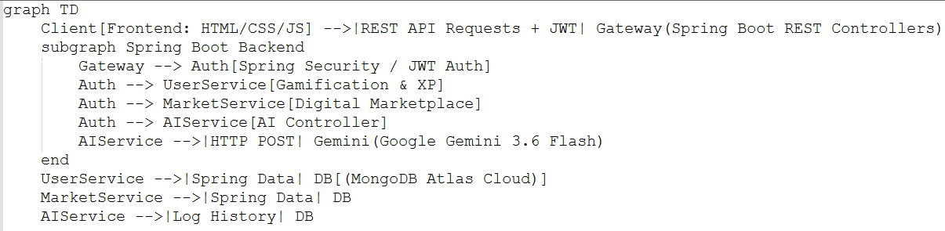
Snippet 2 Website landing page
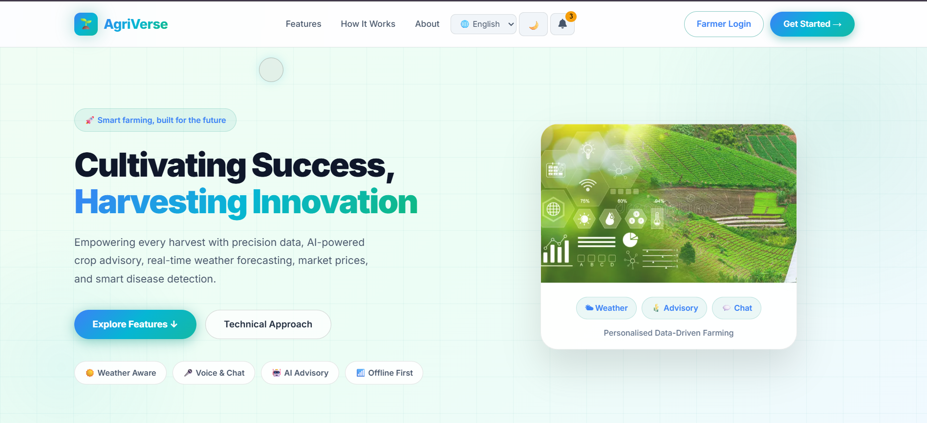
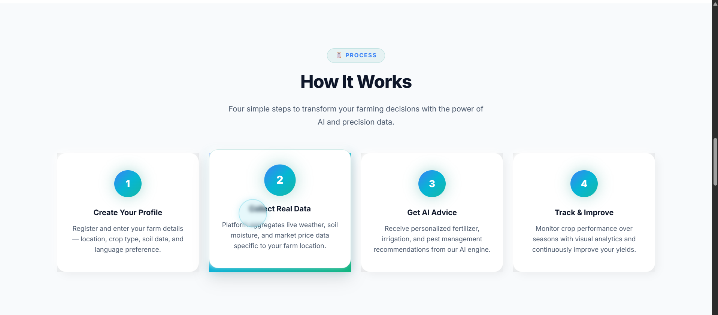
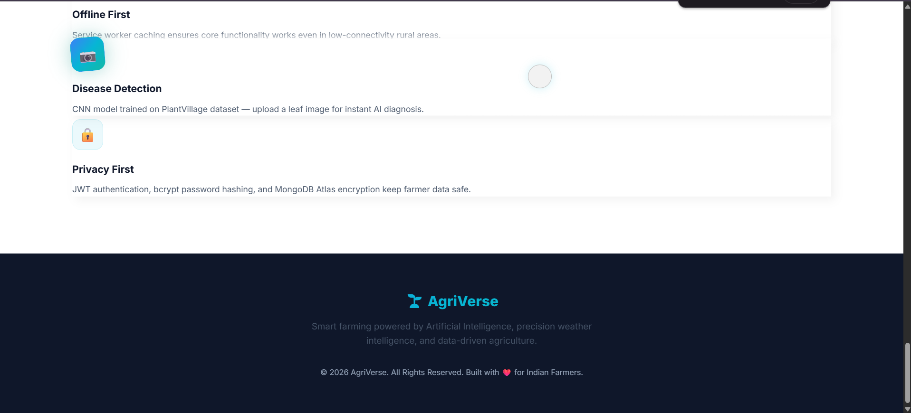
Snippet 3 Secure authentication interfaces featuring role-based login portals for both farmers and administrators
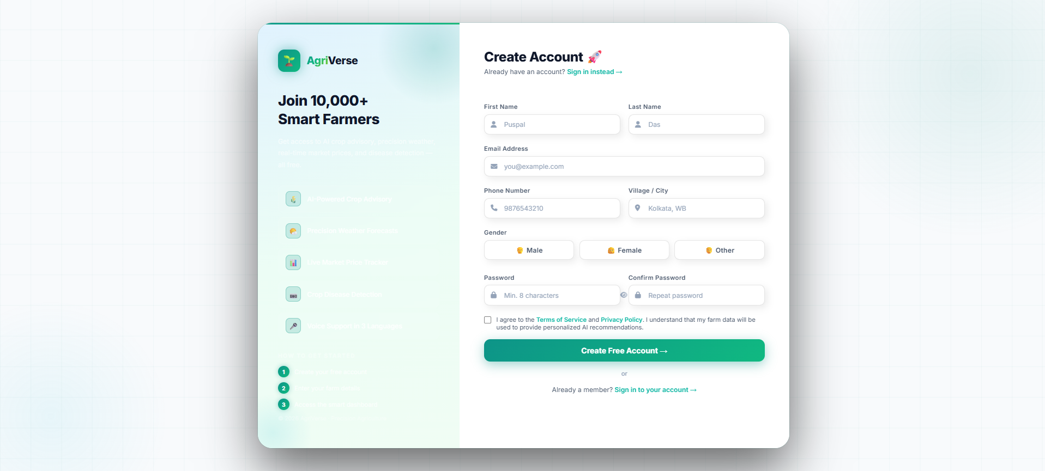
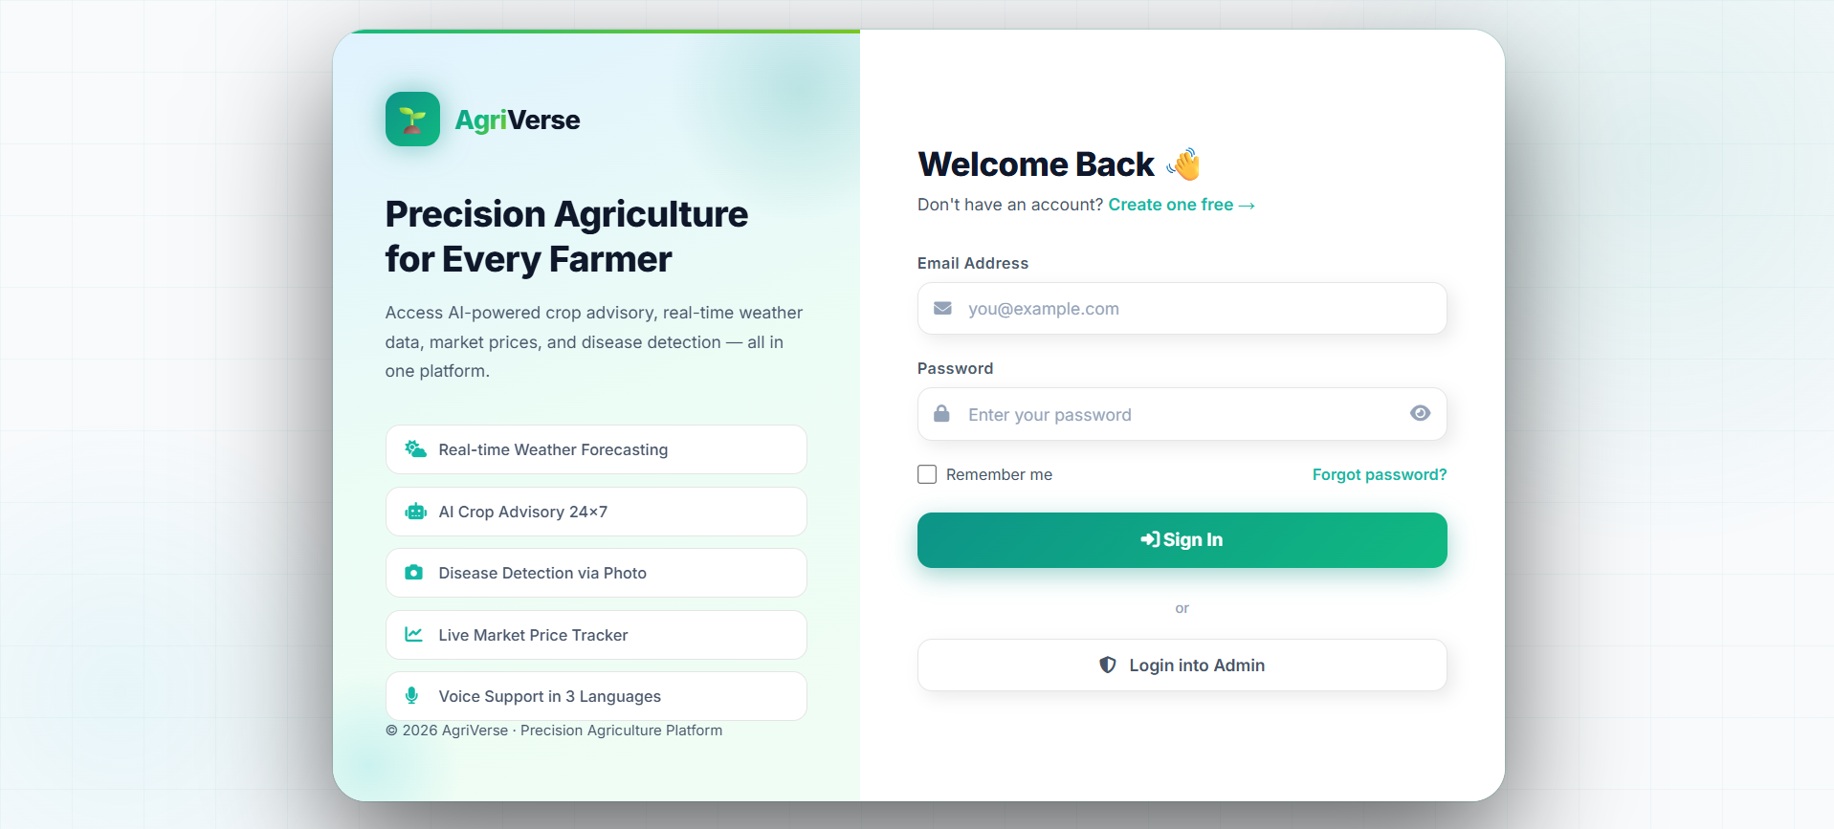
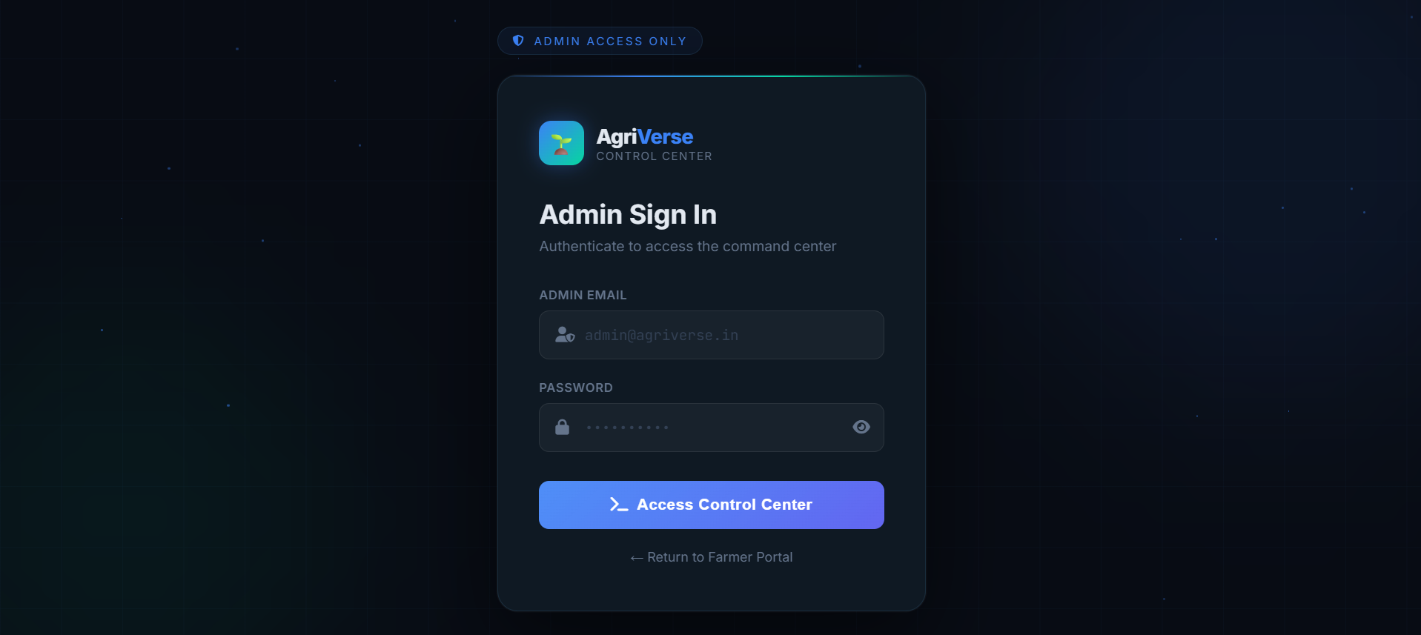
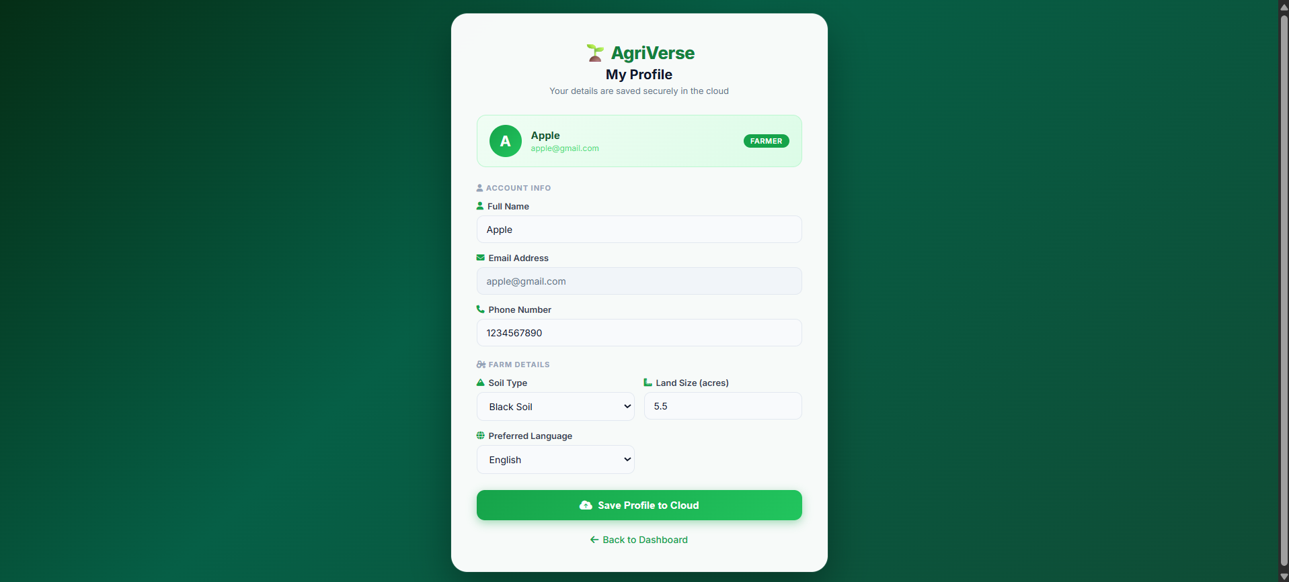
Snippet 4 A highly interactive user dashboard designed to drive farmer engagement through gamification, achievements, and regional leaderboards
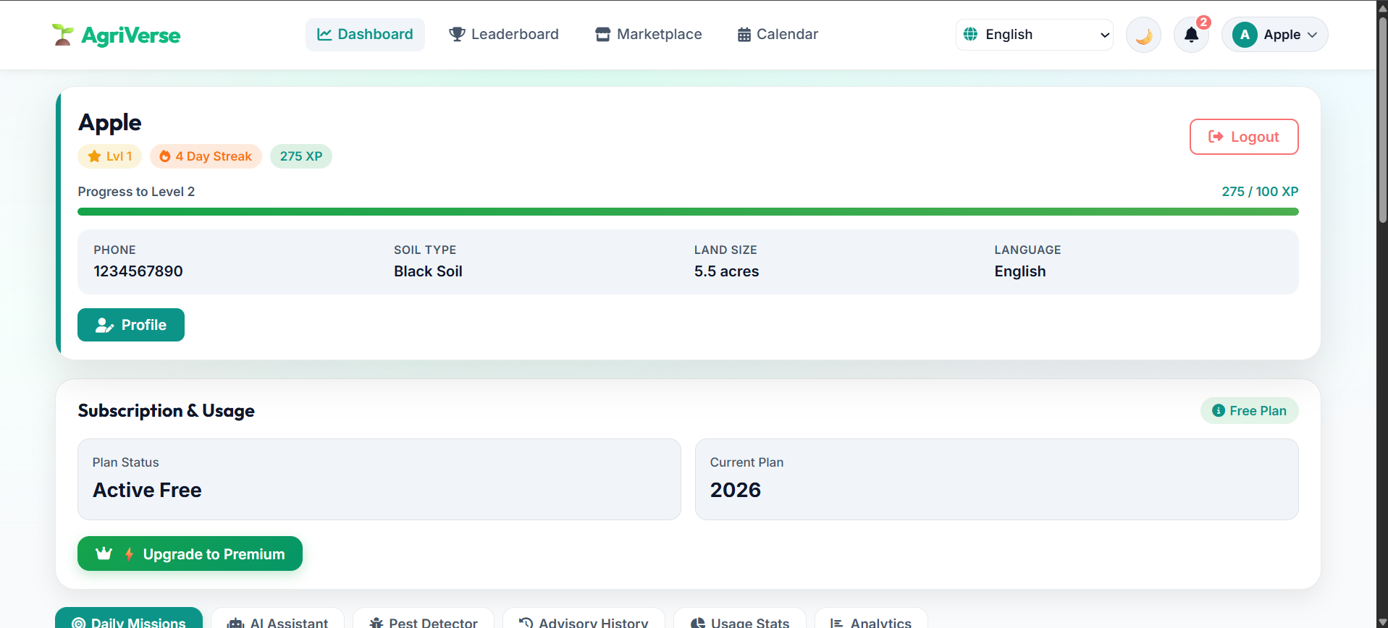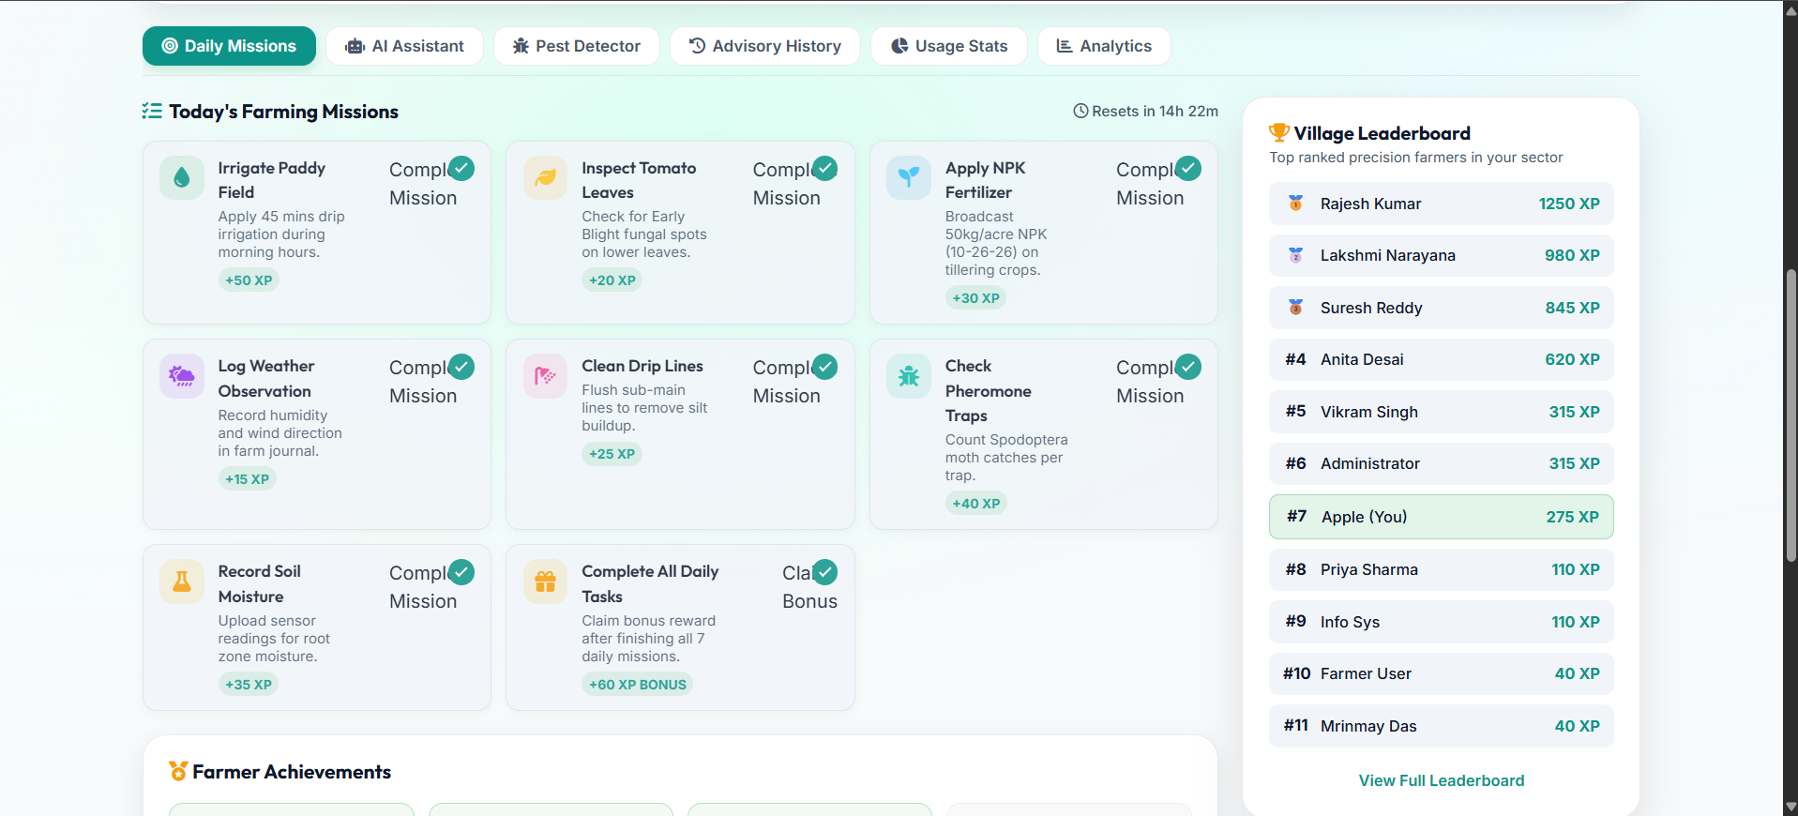
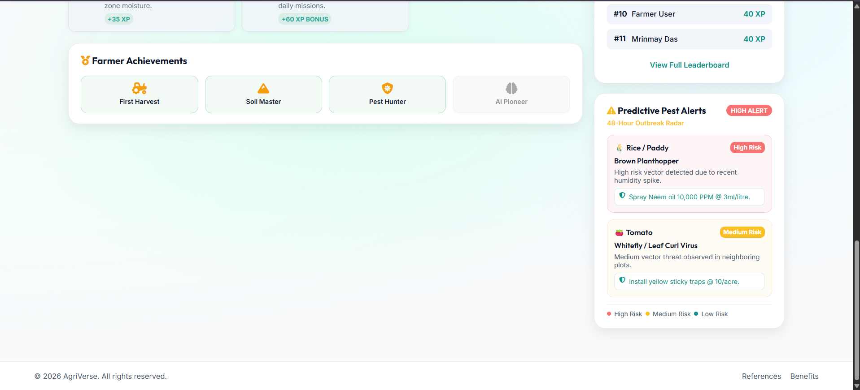
Snippet 5 Integrated AI capabilities and analytics, featuring a real-time Generative AI chat, computer-vision pest detection, advisory history logging, and farm analytics
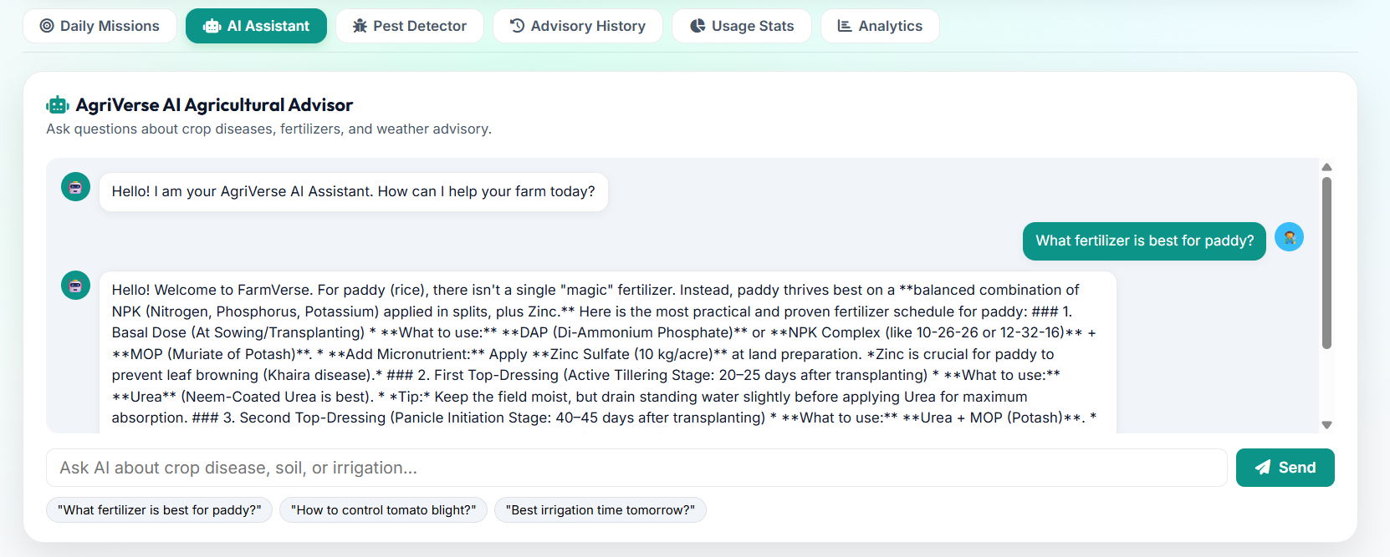
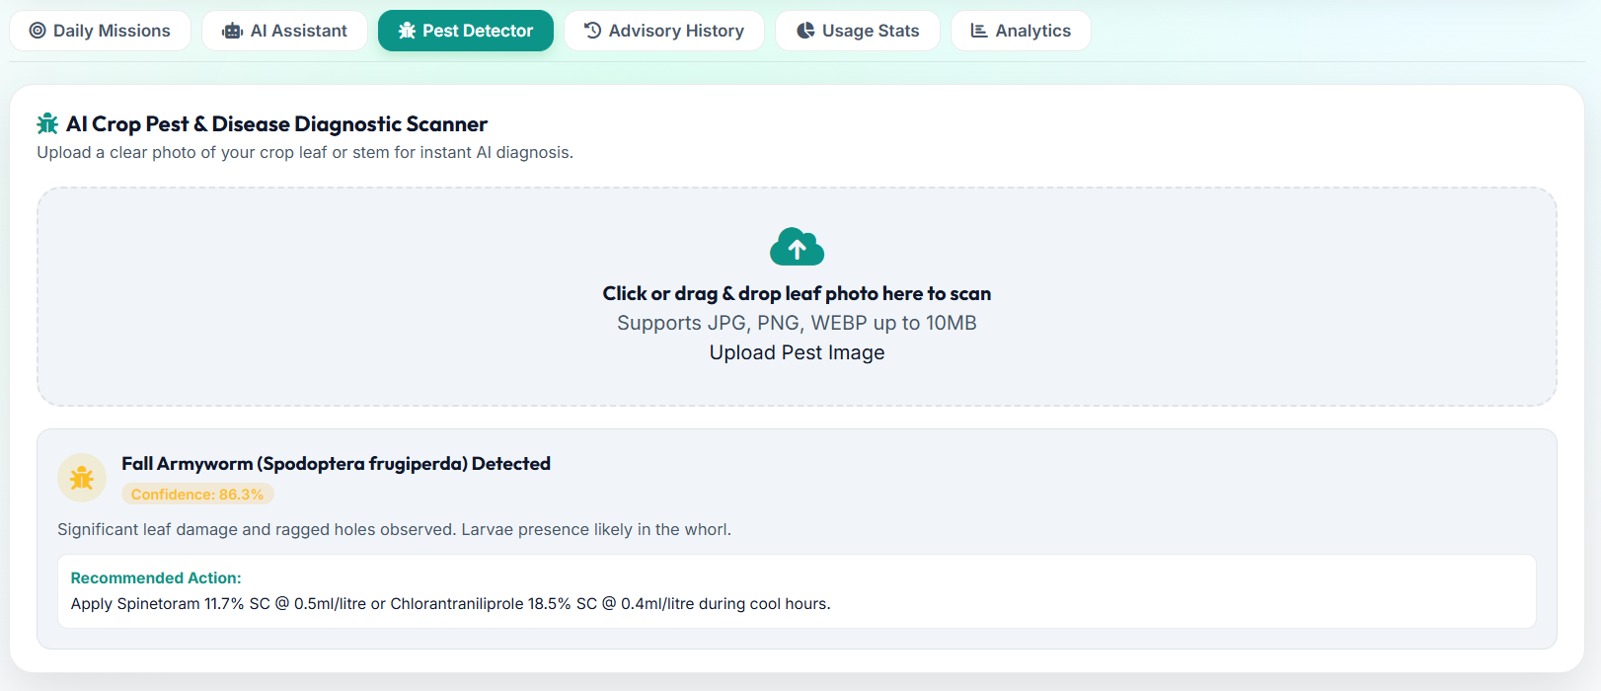
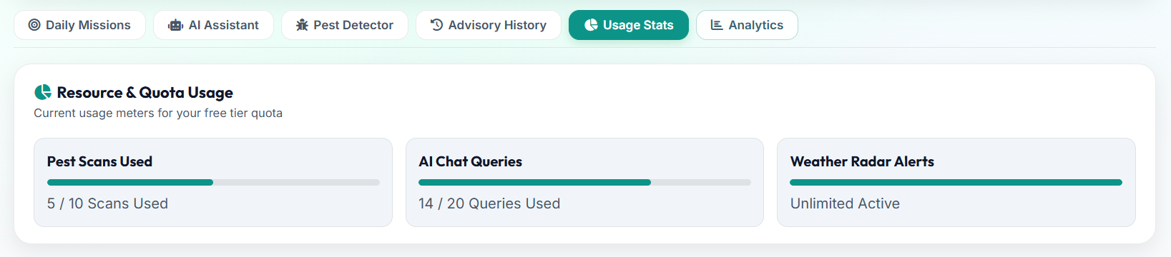
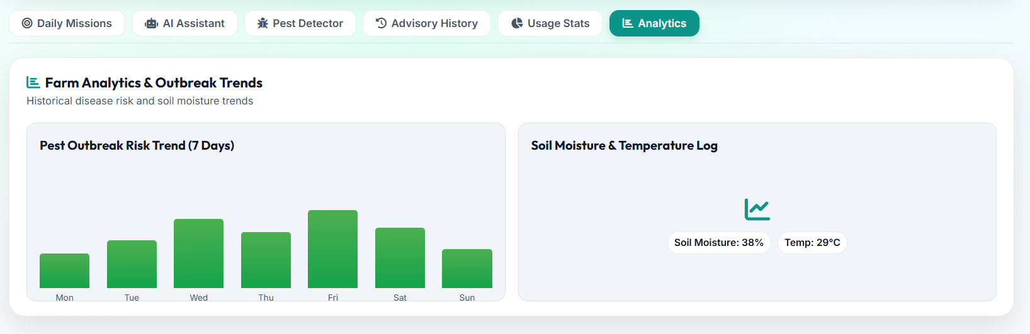
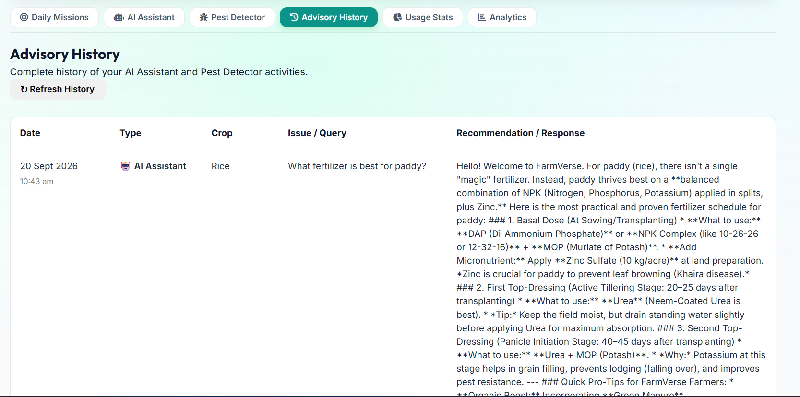
Snippet 6 Direct market integration and visual crop planning modules, designed to optimize farmer profitability and harvest scheduling
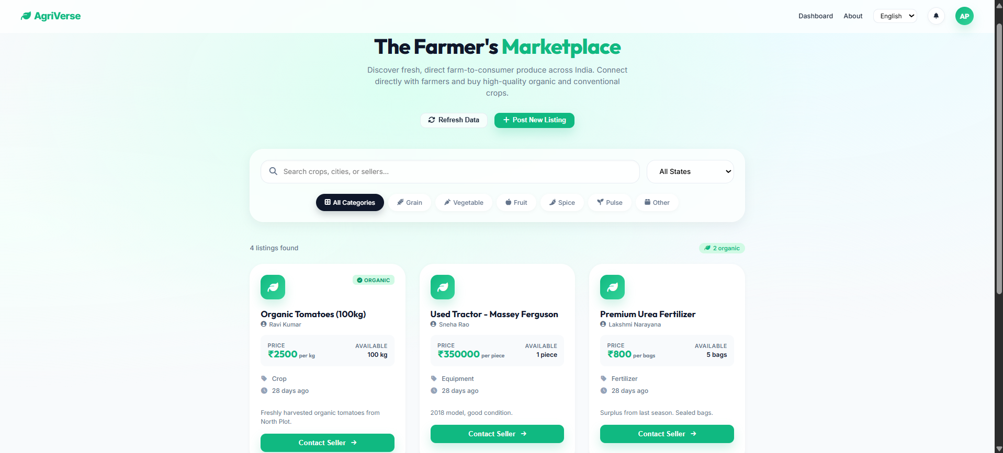
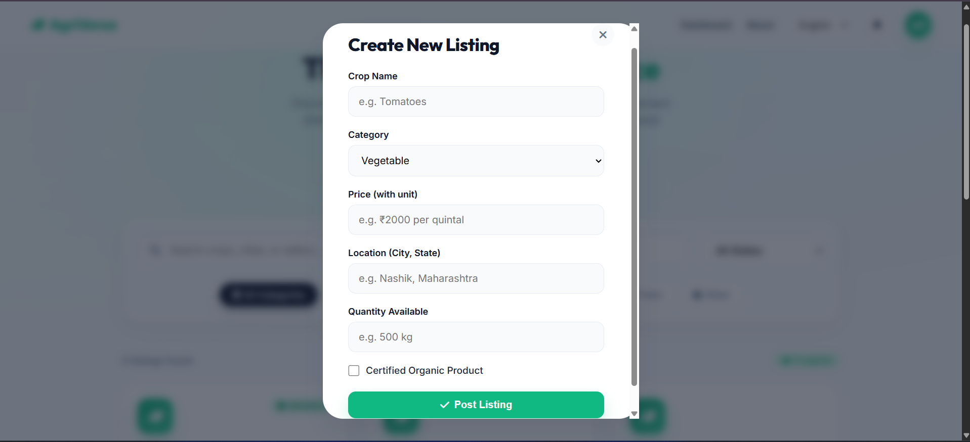

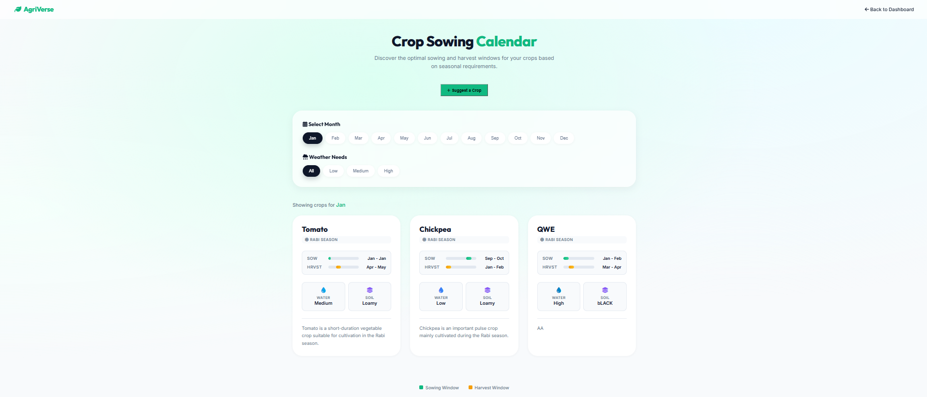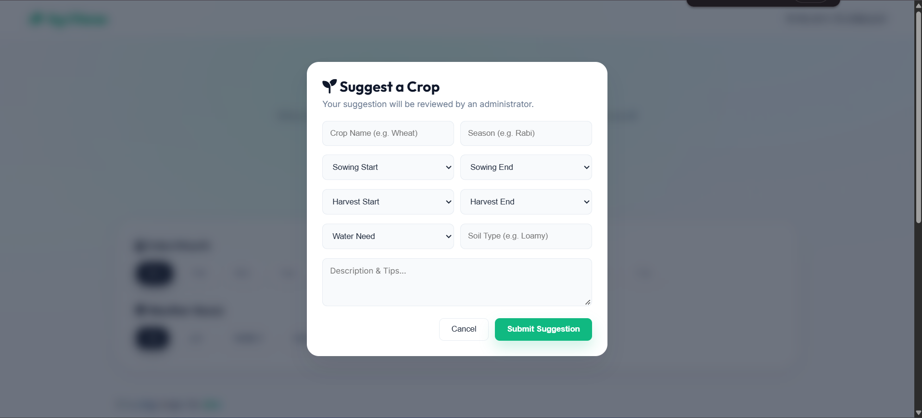
Snippet 7 The secure Admin Command Center, providing centralized oversight for user management, marketplace moderation, dispute resolution, and system analytics.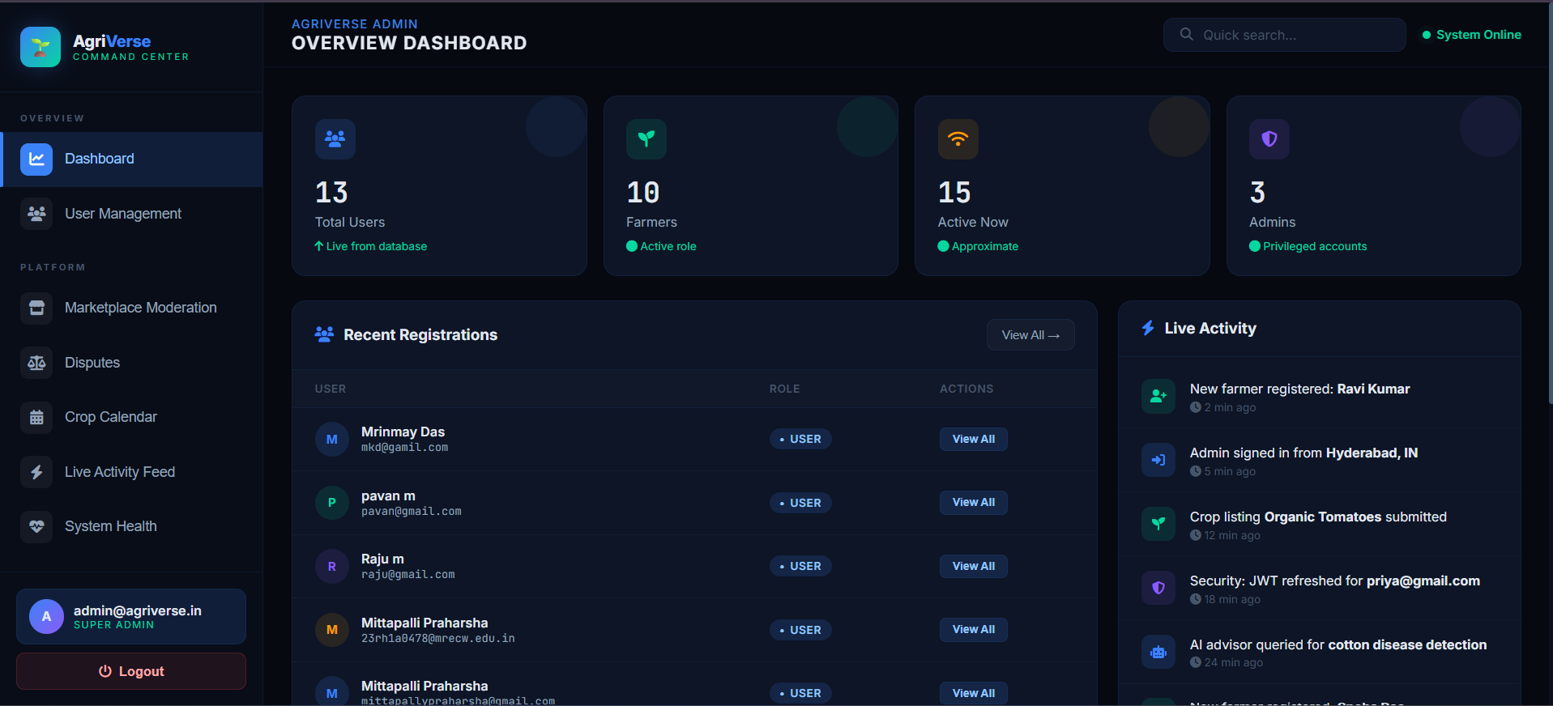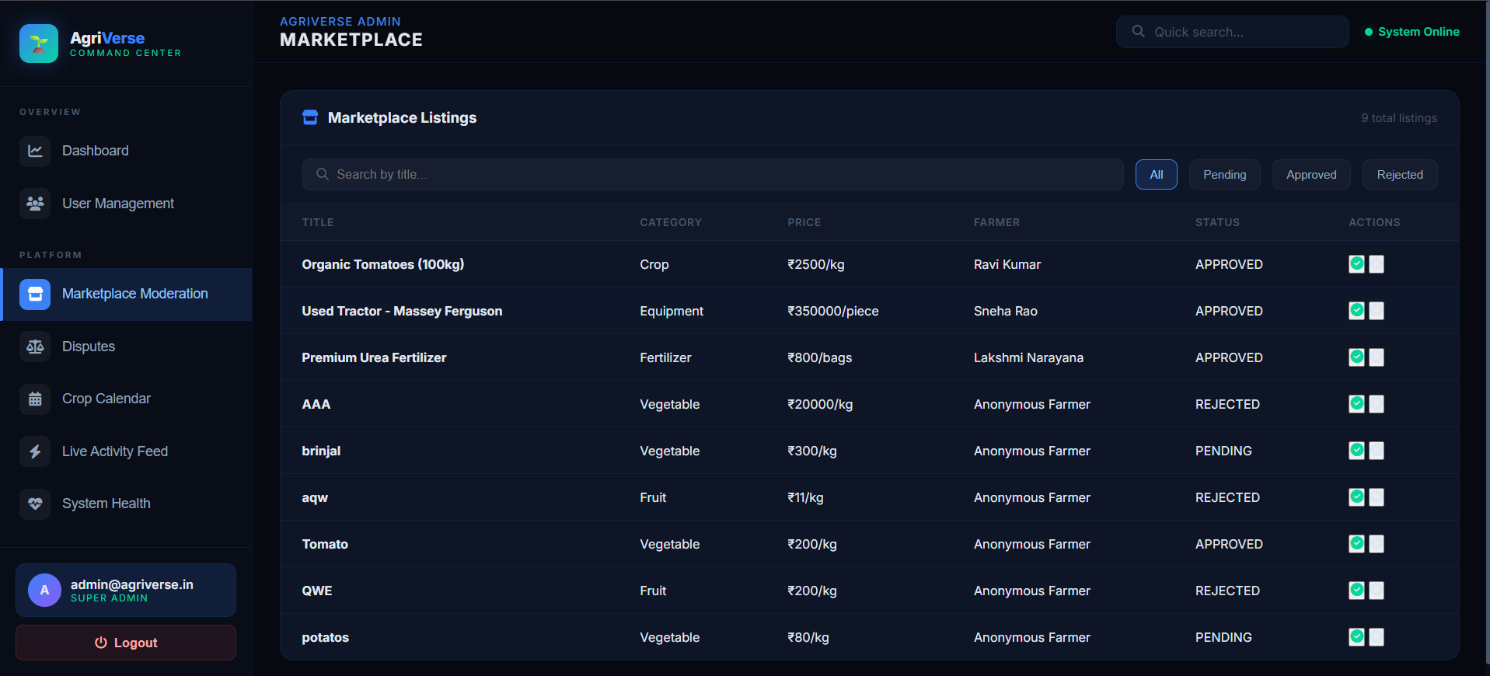
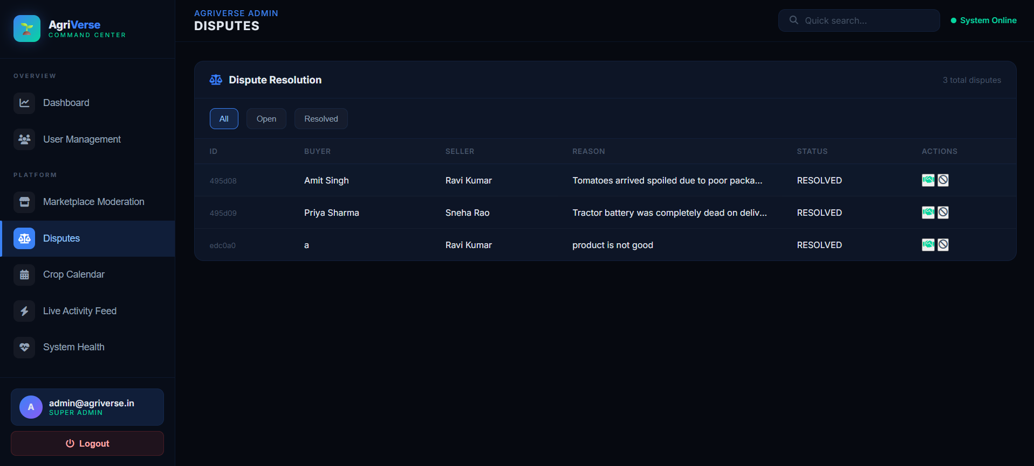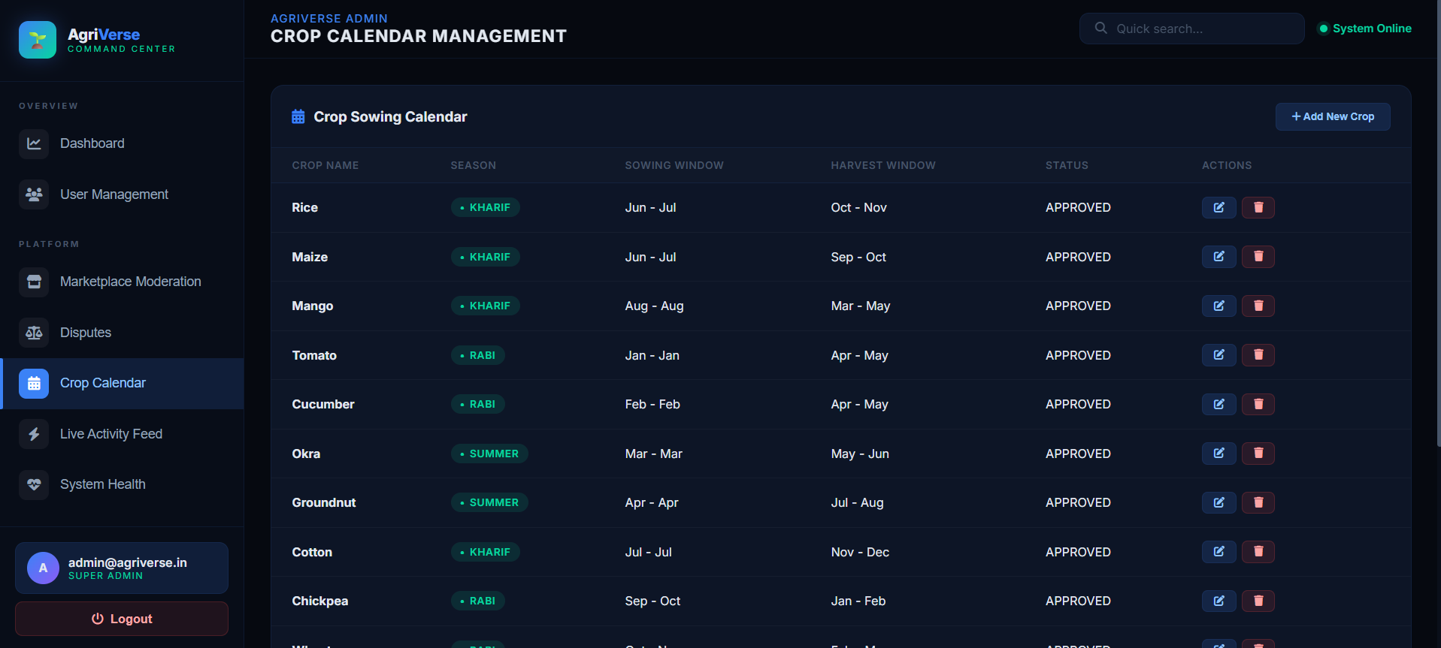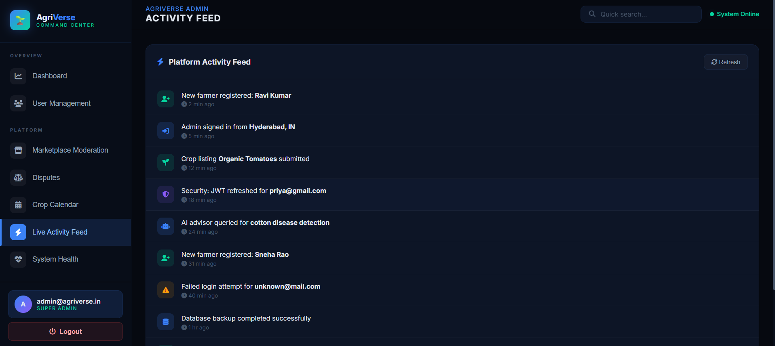
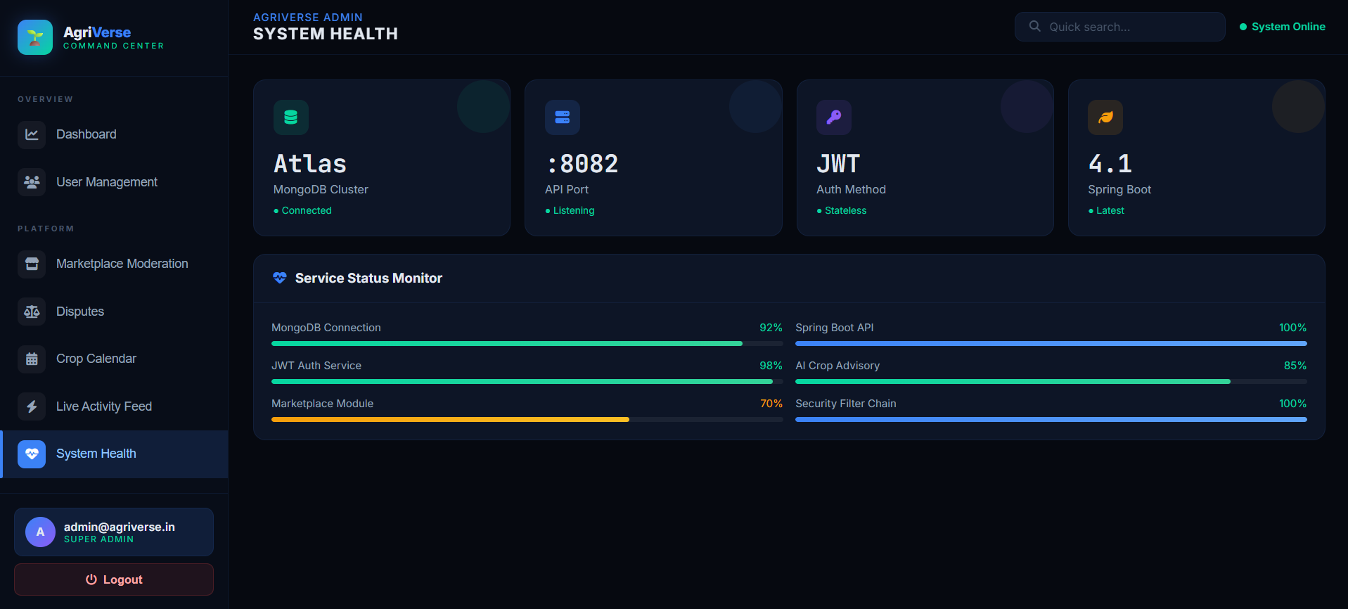
Snippet 8 CODE SECTION
Enterprise Security (JWT Authentication) demonstrates how you securely authenticate a user and generate a stateless JSON Web Token (JWT), ensuring robust Role-Based Access Control (RBAC)
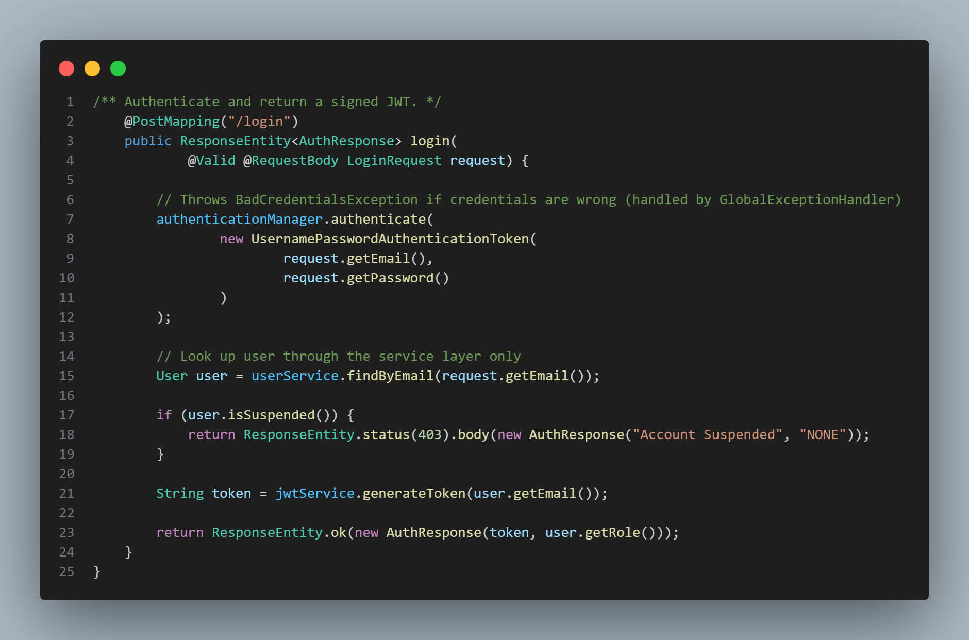
Generative AI Integration with Network Resilience from AIController.java proves you didn't just connect to an API, but you engineered network resilience. It shows the RestTemplate connecting to Google Gemini, with a custom retry loop to handle HTTP 503 Server Overload errors gracefully
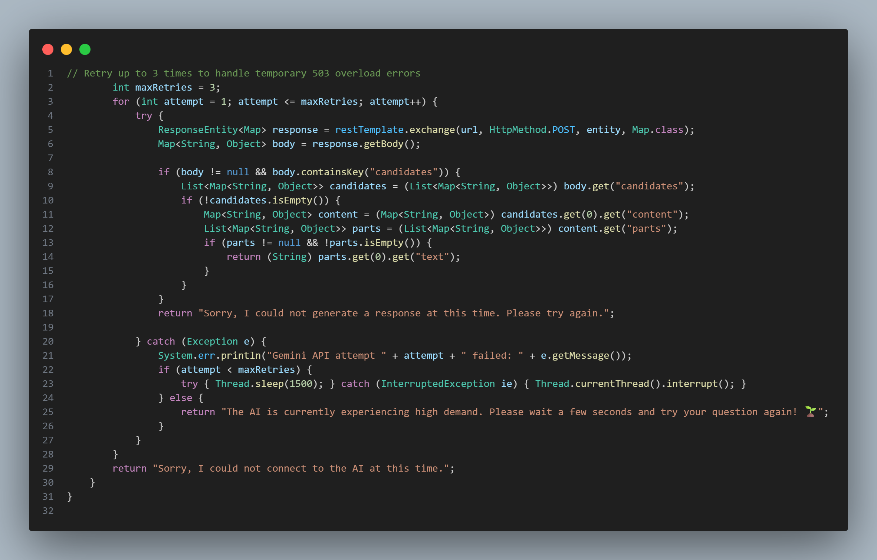
MongoDB Persistence & Workflow Logic This snippet from MarketplaceController.java shows how you interact with the MongoDB Cloud Database. It demonstrates how a farmer submits a marketplace listing and how it defaults to a PENDING status for Admin moderation.
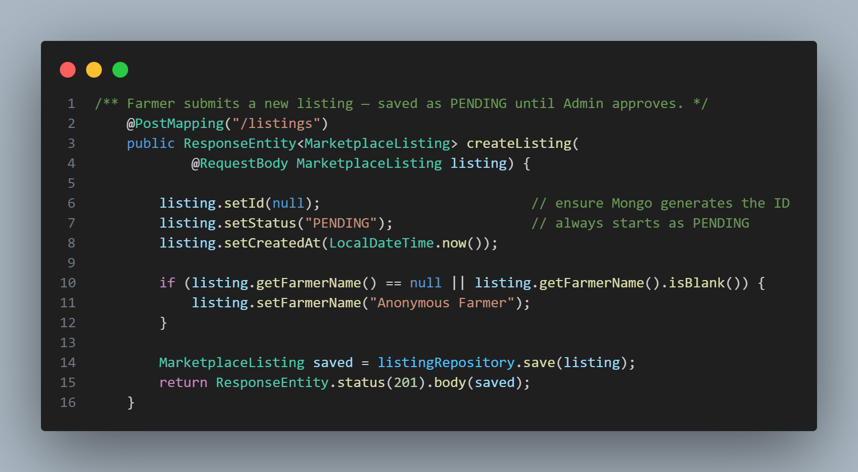
Admin Dispute Moderation (REST API) This snippet from AdminMarketplaceController.java demonstrates how your platform allows Administrators to resolve marketplace disputes. It uses modern HTTP @PatchMapping to update specific fields without altering the whole record.
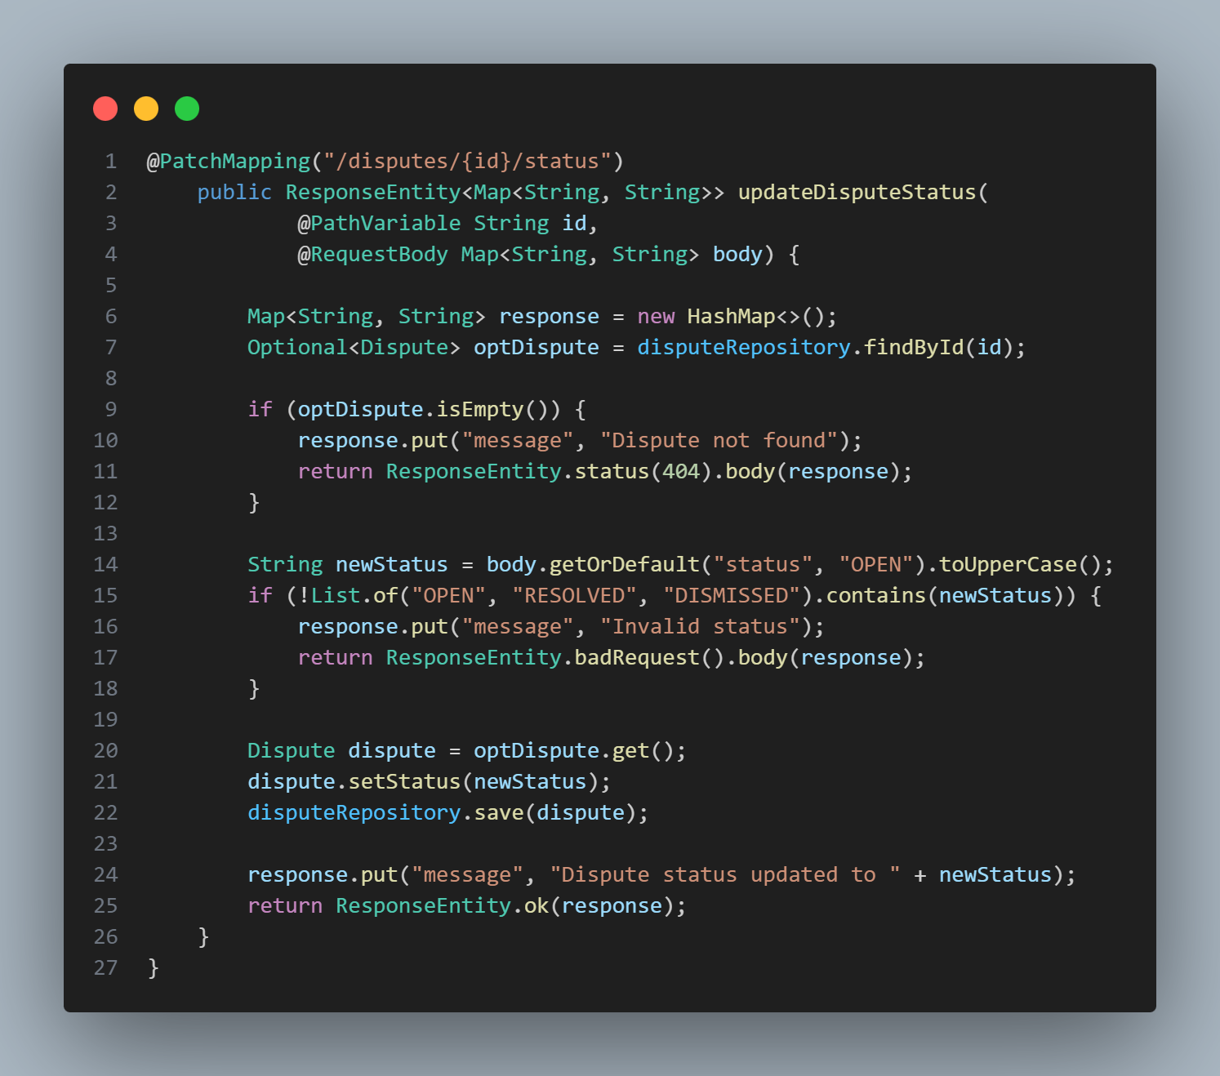
Data Integrity & Exception Handling This snippet from UserService.java demonstrates professional exception handling during the Registration process. It ensures no two users can register with the same email, preventing database corruption.
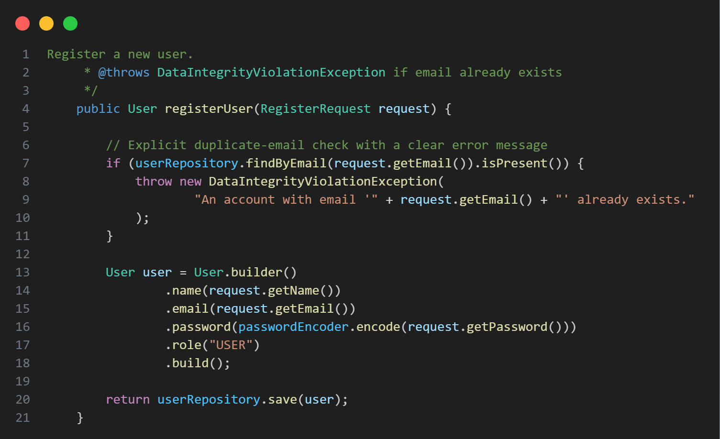
Spring Security Configuration (Endpoint Protection)This snippet from SecurityConfig.java is arguably the most important file in the backend. It proves understand how to build a SecurityFilterChain to protect specific endpoints (like the admin dashboard) while allowing public access to the landing page and login portals. It also explicitly configures the application to be completely STATELESS using JWTs.
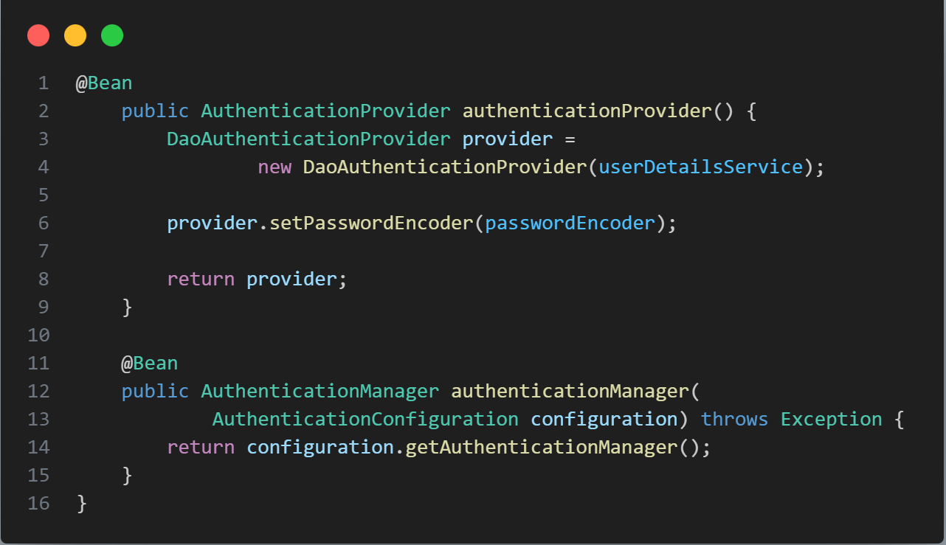

Cloud NoSQL Database Architecture This snippet from User.java showcases how you transitioned away from traditional SQL databases to use a flexible MongoDB NoSQL Document structure. Notice how the Gamification fields (XP and Level) are built directly into the core User model
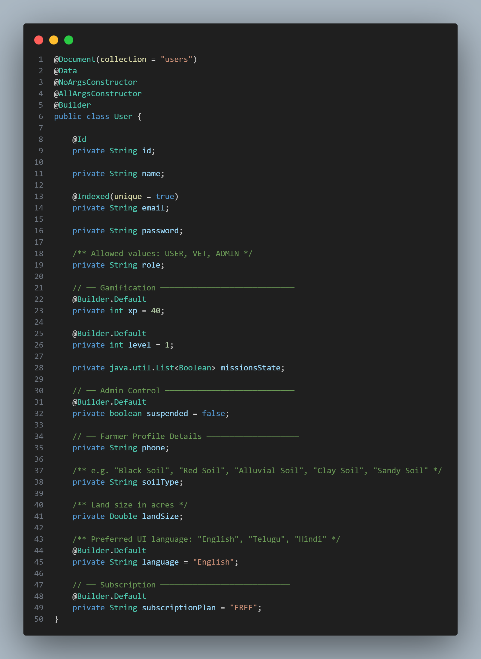

Gamification Engine Synchronization (REST API) This snippet from UserController.java proves how the backend keeps track of the gamification engine. It shows how securely pull the currently authenticated user from the SecurityContextHolder, and update their Experience Points (XP), Level, and Daily Missions in the MongoDB database.
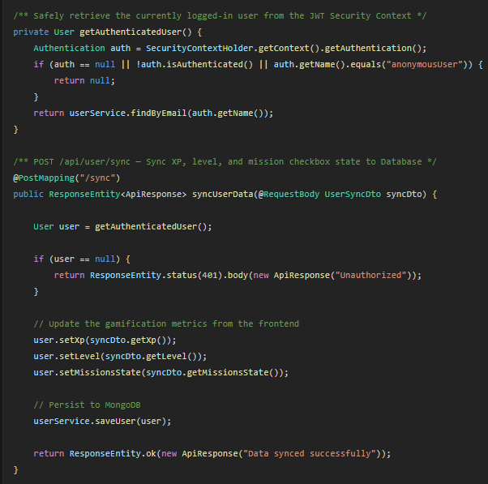

7. Challenges Faced
During the development and integration phases of the FarmVerse project, several technical and operational challenges were encountered. These were systematically addressed through engineering best practices:
1. Technical Challenge: AI API Deprecation and Rate Limiting (HTTP 503 Errors)
- The Challenge: While integrating the Generative AI advisory system, Google updated its AI models, deprecating the older endpoint which caused the application to throw 404 Not Found errors. Furthermore, once migrated to the newer gemini-3.6-flash model, intermittent high server demand caused the API to return 503 Service Unavailable errors, causing the chatbot to crash and fail to return advice to the farmer.
- The Resolution: The backend AIController.java was heavily refactored. The endpoint was updated to the latest model, and a robust Fallback & Retry Mechanism was engineered. A network loop was implemented to automatically catch 503 errors and retry the API request up to 3 times with a 1.5-second delay. If all retries fail, it gracefully returns a user-friendly message rather than crashing the application.
2. Technical Challenge: Secure Credential Management
- The Challenge: Hardcoding the MongoDB database password and the Google Gemini API key directly into the application.properties file posed a critical security vulnerability, especially when committing code to version control (GitHub).
- The Resolution: All sensitive credentials were removed from the source code. The Spring Boot configuration was modified to dynamically inject these secrets at runtime using environment variables (e.g., ${MONGO_PASSWORD}). During execution, these variables are passed directly through the terminal command line, ensuring enterprise-grade security.
3. Operational Challenge: Ensuring High Performance for Rural Users
- The Challenge: Farmers in rural areas often suffer from low-bandwidth internet connections. Building a heavy frontend with large JavaScript frameworks would result in slow load times and a poor user experience.
- The Resolution: A strategic architectural decision was made to discard heavy frameworks (like React.js). The frontend was developed purely using native HTML5, CSS3, and Vanilla JavaScript. To keep the app responsive without reloading the page, asynchronous fetch() API calls were heavily utilized. This resulted in an ultra-lightweight, lightning-fast dashboard that consumes minimal data bandwidth.

8. Learnings & Skills Acquired
During the course of this internship and the development of the FarmVerse project, I gained substantial hands-on experience across the entire software development stack. The project served as a rigorous practical application of computer science principles, resulting in the following key takeaways:
1. Advanced Technical & Tool Skills
- Backend Architecture (Java/Spring Boot): Developed a deep understanding of building scalable RESTful APIs using Java 21 and the Spring Boot framework. Learned how to manage dependencies with Maven and construct a modular Controller-Service-Repository architecture.
- Enterprise Security (JWT): Acquired practical knowledge of implementing stateless authentication using JSON Web Tokens (JWT) and configuring Spring Security for Role-Based Access Control (RBAC).
- Cloud Database Management (MongoDB Atlas): Transitioned from traditional relational databases (SQL) to mastering NoSQL document storage. Learned how to connect a Spring Boot application to a cloud-hosted MongoDB cluster and perform asynchronous CRUD operations.
- Frontend Web Development: Mastered native web technologies (HTML5, CSS3, and Vanilla JavaScript), specifically focusing on asynchronous fetch() operations to build dynamic, single-page-like applications without relying on heavy frameworks.
2. API Integration & Cloud AI Implementation
- Generative AI Integration: Gained cutting-edge experience working with Large Language Models (LLMs). Successfully integrated the Google Gemini 3.6 Flash API into a Java backend using Spring’s RestTemplate.
- Network Resilience Engineering: Learned how to handle real-world network instability and API rate limits by writing custom exponential backoff and retry logic to mitigate HTTP 503 server errors.
3. Domain Knowledge & Operational Security
- Credential Abstraction: Learned the critical importance of cybersecurity best practices, specifically how to abstract sensitive data (API keys, database passwords) out of source code and into system environment variables.
- Agri-Tech Domain: Developed a strong understanding of how software can solve socio-economic problems, specifically regarding how gamification and digital marketplaces can directly empower the agricultural sector.
4. Soft Skills & Professional Growth
- Problem-Solving & Debugging: Enhanced my ability to read stack traces, diagnose server crashes, and independently research and resolve API deprecation issues.
- Agile Execution & Architecture: Learned how to take an abstract problem statement, design a full system architecture diagram, and execute it phase-by-phase into a production-ready application.

9. Testimonials from team
Our Experience Working on the FarmVerse project as part of Team C has been an incredibly rewarding and transformative experience. From day one, our team was united by a shared vision: to build a piece of software that wasn't just technically impressive, but could actively solve real-world problems for the agricultural community.
The internship provided us with a fast-paced, collaborative environment that mirrored professional software engineering teams. We learned the true value of clear communication—especially when debugging complex integrations between the frontend dashboard and the Spring Boot backend. Whenever we encountered roadblocks, such as navigating the deprecation of AI API endpoints or securing our MongoDB database, we tackled the problems collaboratively, sharing documentation and brainstorming architectural solutions together.
Key Success Points & Highlights
- Delivering a Full-Stack Product: We successfully took an abstract concept and turned it into a fully functional, end-to-end web application. Seeing our Java backend and Vanilla JS frontend successfully communicate for the first time was a major milestone.
- Mastering Generative AI Integration: One of our proudest moments was successfully implementing the Google Gemini 3.6 Flash API. Overcoming the initial 503 Service Unavailable network errors by engineering our own custom retry-logic gave us immense confidence in our backend programming skills.
- Implementing Gamification: Successfully coding the Experience Points (XP) and Daily Missions engine proved our ability to think beyond basic CRUD applications and focus heavily on user psychology and retention.
- Security Implementation: We are highly proud of successfully securing the application. Transitioning from hardcoded data to injecting environment variables and implementing JSON Web Tokens (JWT) proved that we can write enterprise-grade, secure software.
Final Thoughts Ultimately, this project bridged the gap between academic theory and industry reality. We walk away from this internship not just as students who know how to code, but as a cohesive team of developers capable of planning, executing, and deploying modern, secure, and AI-driven software architecture.

10. Conclusion
The internship has been an exceptionally enriching and defining milestone in my academic and professional journey. The overall experience of architecting, developing, and deploying the FarmVerse platform allowed me to transition from understanding theoretical computer science concepts in a classroom to applying them in a high-stakes, real-world software engineering environment.
Impact of the Internship The impact of this internship was two-fold. Technically, it dramatically accelerated my proficiency as a Full-Stack Developer. I gained invaluable, hands-on experience working with industry-standard technologies—from securing Java Spring Boot APIs with JSON Web Tokens to managing cloud-based NoSQL databases via MongoDB Atlas, and successfully integrating cutting-edge Generative AI using Google Gemini. Professionally, it instilled in me an engineering mindset. I learned that software development is not just about writing code; it is about architecture, cybersecurity, error mitigation, and creating user-centric designs that solve genuine socio-economic problems.
Alignment with Academic and Career Goals This internship aligns perfectly with my long-term career goal of becoming a Senior Software Engineer specializing in scalable web applications and AI integrations. Building FarmVerse directly contributed to my academic focus on web technologies, database management, and software engineering life cycles (SDLC). The experience of leading a project that actively addresses the technological gap in the agricultural sector has also inspired me to seek out future roles where I can leverage modern software, such as cloud computing and artificial intelligence, to build products that deliver meaningful, positive impacts on society.
Ultimately, this internship provided the exact technical foundation, professional confidence, and industry exposure required to excel in the modern tech industry.

11. Acknowledgements
I would like to express my sincere gratitude to Infosys Springboard for providing the opportunity and resources to undertake this internship. This experience allowed me to bridge the gap between academic theory and practical software engineering.
A special thanks goes to my Project Guide, Ragul S. our technical expertise, patient mentorship, and valuable feedback were instrumental in the successful development of the FarmVerse platform. Thank you for guiding me through the complexities of Full-Stack development and AI integration.
Finally, I am deeply thankful to my fellow teammates in Team C. The collaborative spirit, shared dedication, and late-night debugging sessions made this journey incredibly rewarding. Turning the FarmVerse concept into a fully functional reality would not have been possible without our collective teamwork.

